QUESTIONS AND ANSWERS – ON-LINE PATHWAY SELECTION FOR THE Senior Fresh YEAR
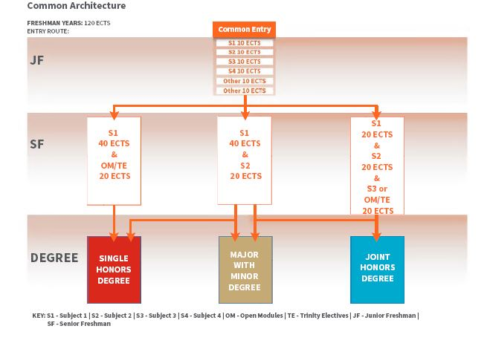
- At this point you are being asked to choose your Pathway for the Senior Fresh year. You must choose from one of the specific pathways available to you right now (see above) – Single Honor, Major with Minor, Joint Honor (and there is a fourth option Three Subjects).
- What you choose right now in your Senior Fresh year is not necessarily what you will choose to exit with i.e. you get the chance to ‘change’ pathway in the Junior Sophister year – Major with Minor (SF) to Single Honor (JS), Major with Minor (SF) to Joint Honor (JS), Joint Honor (SF) to Major with Minor (JS), Three Subject (SF) to Joint Honor or Major with Minor (JS).
Example, your intention is to exit college with a Major/Minor degree, which advises you must take 40 credits in Subject 1 and 20 credits in Subject 2 in the Senior Fresh year. But, you can also see that in the Senior Fresh year, if you choose the Joint Honor pathway in your Senior Fresh year (20 credits in Subject 1, 20 credits in Subject 2, 10 credits in Open Modules, 10 credits in Trinity Electives), you can still realise Major with Minor exit degree. So, really, in the Senior Fresh year you decide your preference 40:20 or 20:20:20 and then make your final decision in the Junior Sophister year.
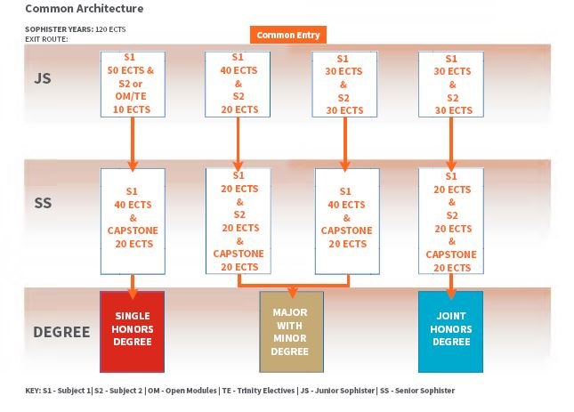
SAMPLE OF QUESTIONS I RECEIVED
Q: | When do I choose my Pathway?
A: | Academic Registry will write to all students inviting them to register online for their pathway. This generally takes place shortly after publication of annual results.
Q: | When do I choose my modules?
A: | Academic Registry will write to all students inviting them to register online their for their modules. This is expected to take place mid-late-July.
Q: | What happens if I was off books this academic year?
A: | Academic Registry have advised that off-books students, taking assessment, will be invited to register online for both pathway and module selection at the same time as all other students. Off-books students, not taking assessment, will advise me of their Pathway of choice when invited to do so and, once received from a student, I will deliver this information over to the Online Module Enrolment (OME) team and they will assign your pathway to you in readiness for online module choice in late July.
Q: | When do I get to choose my Trinity Electives?
A: | Trinity Electives will be chosen at the same time as all other module selection.
 | SENIOR FRESH RELATED QUESTIONS
Q: | I just have one question relating to Designated Open Modules and Trinity Electives. I am continuing with Economics and Politics. I was wondering if I could take 20 credits economics modules, 20 politics and 10 credits of Trinity Electives and 10 credits Designated Open Modules? If so, would my chosen pathway be Economics and Politics?
A: | Yes – via the Joint Honor pathway
Q: | I am just wondering for our designated open module choices are we able to select open modules in a subject that is part of our joint honour choices. i.e. if I am taking economics as 20 credits for subject one, can I pick further economics modules as part of my designated open module choices or do I have to pick designated open modules from outside the subjects I am continuing with?
A: | You can choose what are termed Designated Open Modules from within the Subject 1 or Subject 2 you are pursuing e.g. for Economics, ECU22011/12 and ECU22031/32 are mandatory anyway, but nothing prevents you from taking ECU22021/22 as your 10 credits of Designated Open Modules. (Common Entry students do not have the college-wide Open Modules available to them within their programmes).
Q: | I want to choose the single honour of business in the second year, but I still have two questions related to the DOMs and Trinity electives. It was shown that students take 20 ECTS by : 10 ECTS from the list of designated open modules and 10 of Trinity electives, or 20 ECTS from the list of open modules
A: | You have to choose 10 ECTs from the list of Designated Open Modules and 10 ECTs of Trinity Electives.
Q: | looking to do 20 credits of Business, 20 for Politics and 20 for German. I understand that the German module for SF is only ten credits, but in this case I would have 10 credits free to choose?
A: | It is not possible to do 20 credits in German. There are only 10 credits of German made available on the programme and they can only be chosen if you took the German module in your JF year. Here you would be choosing the Joint Honor options 20:20:20 ECTs – 20 Business, 20 Politics, 10 German (from the list of Designated Open Modules), 10 Trinity Electives
Q: | I am a rising JF student and would like to do 30 credits in business and 30 in economics. On the portal, do I click business and economics or economics major and business minor?
A: | In the SF year there is no option to take 30 credits in Economics and 30 credits in Business (that comes in the JS year). You choose to take 40 : 20 via the Major/Minor route or 20 : 20 via the Joint Honor route, with a further 10 credits of either business or economics via the Designated Open Modules (if pursuing JH and if you wish to take DOMs from within your subjects).
Q: | Going by the BESS handbook, the open modules available to us are simply any modules from the course that we are not already taking as part of our subject 1/subject 2 combination. I am leaning towards pursuing a major/minor degree with 20 credits in subject 1/ 20 in subject 2 and then 20 credits from open modules and electives. If this is the case, could I pick economics as my subject 1, taking 20 credits in it, and then take 10 more credits in the remaining economics modules from the list of open modules, thus leaving me effectively taking 30 credits in economics, 20 in my subject 2 and the remaining 10 from trinity electives?
A: | What you advise above is not available via the Major Minor pathway in the SF year but rather the Joint Honour pathway (though you can pursue the JH in the SF year and move over to M/M in the JS year). Modules from all four BESS disciplines along with modules in Law, Social Policy, Languages etc are what make up the Designated Open Modules available for BESS students. And, yes, if choosing the Joint Honor route in the SF year, you can choose a further Economics module from the list of Designated Open Modules. This then enables you to move into the Major/Minor in the JS year, if that be your preference.
Q: | I would like to pursue a degree in business and Spanish. There is no option to choose the Spanish; should I just choose business and have Spanish added on at a later time?
A: | You might be on the wrong programme! Spanish is only available to BESS students via the list of Designated Open Modules and, of course, only if you have chosen its pre-requisite from the Junior Fresh year. Thereafter, in the Sophister years, there are no Spanish modules on offer to you.
Q: | I would like to continue business, economics and politics next year in equal measure. I am wondering how many modules of each subject I will need to choose and if there are any modules that are necessary to continue on with it a subject in third and fourth year as I am unsure which I will keep on
A: | You will need to choose the Three Subject pathway where you can choose the 20 credits in Business, 20 credits in Economics, 20 credits in Politics (listed as BESS Business, Economics, Politics when you go to make your pathway choice). The Subject 1 20 credits, Subject 2 20 credits and Subject 3 20 credit choices are constructed so that you can, with confidence, change onto the Joint Honour pathway or the Major Minor in the JS year. You must drop one of the three Subjects as you move into the Junior Sophister year.
Q: | If I choose to take 20 credits in Business, economics and sociology in Senior Fresher year does this mean I cannot take the sociology modules; Introduction to social research 1 and social theory 1.
A: | Yes, you can of course choose to take Social Research and Social Theory as your sociology modules. This will then enable you to continue on with Sociology into the Junior Sophister year and, furthermore, if you choose the mandatory sociology module in the JS year, you will then be programme compliant to take the Capstone in sociology, if you wish to do so.
Q: | I am planning on choosing a Joint Honours pathway of Business and Economics. I would love to be able to take a language module and do French however I did not take French this year, I took a law elective. I was wondering if it is possible for me to do French in the upcoming academic year considering I did not do it in first year.
A: | It is not possible to take up a language module if you have not done its pre-requisite module in the JF year. You can, of course, seek to choose a Trinity Elective in French Language.
Q: | Is it possible to keep on German with the major w/ minor pathway and also the joint honours pathway?
A: | In this example, it is possible to keep on German but only by choosing either (a) the Major in Economics or Political Science (where they are available as core optional modules as there are not 40 credits of pure economics or political science modules in place) or (b) the Joint Honour pathway if choosing any of disciplines and you choose German as your Designated Open Module. Joint Honour can then change into the Major with Minor pathway in the JS year. By choosing Major with Minor in the JS year you are making definitive your exit award i.e. Major with Minor.  Languages can be chosen in the SF year if taking (a) the Single Honour pathway in any of the four disciplines, (b) the Major in Economics or Politics, (c) the Joint Honour pathway 20 Subject 1, 20 Subject 2, 20 DOM/TE. It is not possible to choose a language if choosing the Three Subjects pathway.
Q: | I have looked at the BESS handbook you sent us for the single honor Economics as that is what I'd like to do next year. However, I do not understand why it says that I will be doing 40 ECTs in Economics when only 30 ECTs are available.
A: | There are only 30 credits of dedicated Economics modules available (as, indeed, is the case for politics). The final 10 credits applied against Economics or Politics comes from within a full range of other core optional modules that are made available and satisfy the Departments of Economics and Political Science in this regard. These are listed under the Single Honour Economics and Single Honour Political Science entries in the Handbook.

SENIOR FRESH RELATED QUESTIONS
Q: | I chose a single honour pathway in the SF year, what options are now open to me for the JS year?
A: | You must continue with the Single Honour pathway in your Sophister years. You cannot choose to pick up on another subject/discipline in your JS year that you had dispensed with in your SF year.

Q: | I chose the Major Minor pathway in the SF year, what options are now open to me for the JS year?
A: | You can choose to move over to the Single Honour Pathway, continue on with the Major Minor Pathway, or move over to the Joint Honour Pathway.

Q: | I chose the Joint Honour pathway in the SF year, what options are now open to me for the JS year?
A: | You can choose to continue on with the Joint Honour Pathway, or move over to the Major Minor Pathway.

Q: | I am eligible to choose the Major Minor pathway in my JS year but I see that there is an Option ‘A’ and an Option ‘B’ available to me ?
A: | If choosing to pursue the Major Minor in the JS year you are obliged to identify whether you are choosing the ‘A’ or the ‘B’ option. Choosing the ‘A’ option will result in your choosing 40 credits in Subject 1 and 20 credits in Subject 2 in both the JS and the SS years (your Capstone project will be included within the 40 credits of Subject 1 in the SS year). Choosing the ‘B’ option will result in your choosing 30 credits in Subject 1 and 30 credits in Subject 2 in the JS year and then all 60 of your credits in Subject 1 in the SS year.

Q: | I chose the Major Economics and the Minor Business pathway in the SF year. Is it possible for me to swap these around in the JS year?
A: | Yes. You can choose to change your Major Economics to Minor Economics, and your Minor Business to Major Business, in your JS. However, you need to be ever mindful of pre-reqs applied to JS business modules and that you are, in fact, in a position to successfully choose 40 credits in business in your JS year.

Updated by MNíC March 2023

